Self-Sustaining Renewable Energy House Circuit

EENG 1910: Project Proposal
By: Tsedenya A, Aron H, Cameron H
Date: March 26, 2026

Table of Contents

- Introduction 3
- Project Overview 3
- Methodology and System Design 4
- Work Breakdown Structure 5
- Project Timeline 5
- Budget Analysis 6
- Ethical and Legal considerations 8
- References 8

Introduction

Our goal in this project is to design and build a small-scale electrical system that shows how renewable energy sources can power a home. This project gives us students studying electrical engineering the chance to put our academic knowledge to use in a useful and practical way. Our technology will bring together controlled power distribution, energy storage, and solar and wind energy generation to an LED-represented house model.
This project aims to understand how energy moves through a system from generation to final usage in addition to building a functional circuit. We improve our understanding of important electrical engineering ideas like voltage, current, resistance, energy conversion, and circuit safety by creating and putting this system together ourselves.

Project Overview

We will design and construct a self-sustainable renewable energy home circuit that combines solar and wind power into a single integrated system. The system will show how electrical energy is produced, stored, and applied to run a home.
We will create a DC motor that functions as a generator to resemble wind energy. Wind power is represented by electrical energy produced when the motor shaft rotates. We will use a solar cell for solar energy which, when exposed to light, transforms light energy into electrical energy.
Every energy source will have its own storage system and function independently. The generated energy will be transported to the home via regulated circuit pathways after being stored in batteries or capacitors. We will be able to manually choose which energy source powers the house at any given moment thanks to switches. When power is applied, LEDs that represent rooms or devices will glow. Through this project, we can visually illustrate how renewable energy systems operate in a realistic yet simplified manner.

Importance of the Project
Because it shows how renewable energy technologies can be included in a single electrical system, this project is significant. Energy systems in real-world applications frequently depend on several sources to guarantee efficiency and dependability. We demonstrate how various energy sources can cooperate by combining wind and solar energy.
This project also helps us with:
- Apply everything we have learned in class to an actual engineering system.
- Discover and understand the mechanism involved in energy conversion.
- Explore how to create circuits that are both safe and useful.
- Learn how to build and evaluate physical circuits.
We get the technical expertise and critical thinking skills necessary for electrical engineering through this project.

Methodology and System Design

The energy flow in our system is structured as you see in figure 1. Batteries or capacitors are used to store the electrical energy produced by the solar panel and DC motor. Before the energy reaches the output, it passed through a regulated circuit system from the storage.

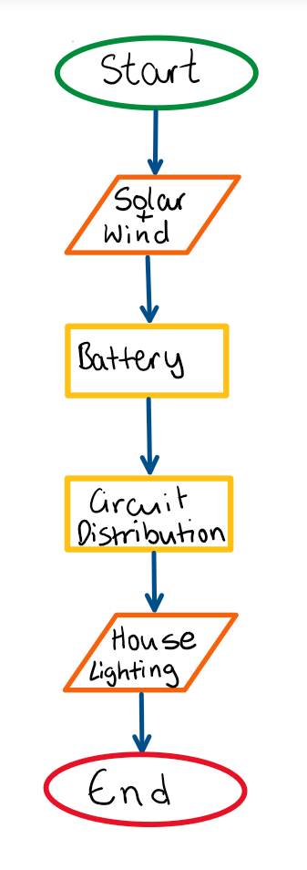
Figure 1. Flowchart
To guarantee optimal functionality, we will incorporate Potentiometers and resistors to regulate current and safeguard components such as:
- Diodes to stop the passage of reverse current.
- Switched for switching between sources of energy.
- Voltage regulator to keep output steady.
LEDs that symbolize a home lighting system will be the ultimate product. A breadboard or mounting board will be used to construct the entire circuit, with sections designated for each system step. The system is guaranteed to be well-organized, easily understood, and functionally sound thanks to this hierarchical design in figure 1.

Work Breakdown Structure

Three people make up our team, and each has been given a distinct task to guarantee the project is completed quickly.
Aron oversees research, mathematical analysis, budgeting for materials and project requirements. Before the system was physically implemented, Cameron oversees developing and simulating the circuit using software tools. Tsedenya oversees overseeing the project schedule, organizing work, and creating the final presentation materials.
Along with these specific responsibilities, each team member will work together to construct the circuit, obtain supplies, put parts together, solder, test, troubleshoot, and deliver the finished product. This collaboration guarantees the successful and effective completion of every aspect of the project.

Project Timeline
A structured overview of the project timeline over a total of 4 weeks is provided by the Gantt Chart in Figure 2. It arranges all the main tasks into a logical order that is in line with deadlines. By keeping a clear path from one work to the next, this visual helps guarantee that every stage of the project is finished within allotted time.
The distribution of tasks across time is placed in the chart, which also illustrates effective time management and planning. We can monitor progress, prevent overlaps, and guarantee that enough time is set aside for both technical development and the end result by giving each project stage a specific time.
Gantt Chart
Tasks | Week 1 | Week 2 | Week 3 | Week 4
Project Requirements + Material Budgeting + Research
Digital Circuit Design/ Simulation
PCB Assembly/ equipment soldering + Physical circuit testing
Presentation
Figure 2: Gantt Chart: Project Schedule
The orderly progression and dependencies between jobs throughout the project are shown in the network diagram below in Figure 3. It describes the order in which each task must be finished, beginning with the with research up to presenting the result.
The network diagram highlights the sequence of operation and how each step depends on the completion of the preceding one, in contrast to the Gantt Chart, which concentrates on time allocation. This lowers the possibility of mistakes and errors by verifying that the project follows a planned course. The diagram helps us maintain order and confirms that no crucial stage is overlooked during development by precisely outlining the interactions between tasks.
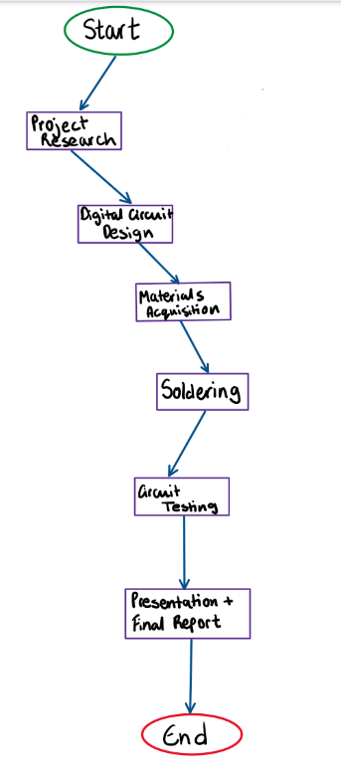
Figure 3: Network Diagram: Task Flow

Budget Analysis
We determined all necessary components and calculated our expenses to finish the project properly as shown below in Figure 4. The objective is to maintain the project’s affordability while guaranteeing its dependability and functionality. We have come to total estimated cost of $51.00.
The project is feasible for student-level implementation while still showing important engineering ideas because these components are available and reasonably priced.
Budget Plan
Component | Quantity | Estimated Price (USD) | Total Cost (USD)
DC Motor | 1 | $8.00 | $8.00
Solar Panel | 1 | $1 | $1
Batteries | 2 | $3.00 | $6.00
Breadboard | 1 | $6.00 | $6.00
LEDs | 6 | $0.50 | $3.00
Resistors | 10 | $0.20 | $2.00
Potentiometer | 1 | $2.00 | $2.00
Diodes | 4 | $0.50 | $2.00
Switches | 2 | $1.50 | $3.00
Capacitors | 4 | $0.75 | $3.00
Voltage Regulator | 1 | $3.00 | $3.00
Jumper Wires | 1 pack | $5.00 | $5.00
Mounting Board | 1 | $7.00 | $7.00
Total |  | $38.45 | $50.00
Figure 4: Estimation of Material cost
Estimating Cost (Man-hours)
Rather than concentrating solely on money expenses, we also calculate the necessary effort:
- Planning and research: 4 hours
- Circuit design and simulation: 5 hours
- Soldering and testing: 7 hours
- Creating Presentation and Report: 3 hours
The expected total effort is about 19 hours.

Ethical and Legal considerations
We shall uphold high ethical standards in this project by making sure that every piece of work is unique, truthfully reported and appropriately documented. We will share responsibilities equally, work as a professional team and avoid any kind of academic dishonesty or falsification.
We shall manage all electrical components carefully and follow fundamental safety regulations during assembly and testing from a legal and safety perspective. These covers making safe connections preventing short circuits and using tools correctly. Even if this is a small-scale project, we will put safety and responsibilities first to avoid harm and guarantee an appropriate and trustworthy result.

References
Excel Worksheet – Design Gantt chart and budget Table
One note – Drawing the Flowchart and Network Diagram
Word - Self-sustaining renewable energy project description

